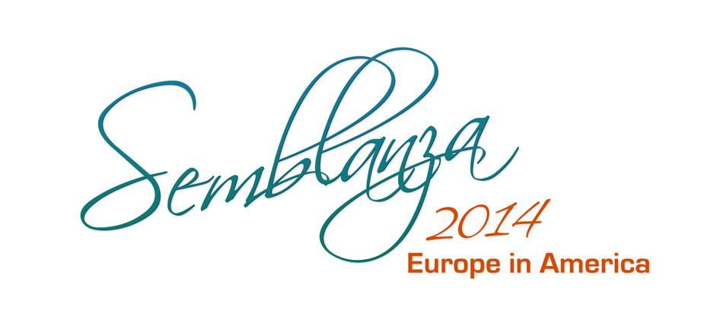
Presents:

Dear Directors, Artists and Folkloric Dance Companies:
Tierra Blanca Arts Center is proud to present the 6th Annual Semblanza 2014, this years theme is “Europe in America”; a colorful, exciting celebration of the Americas and European culture through folk, music & dance by several distinguished Musicians & Dance Companies.
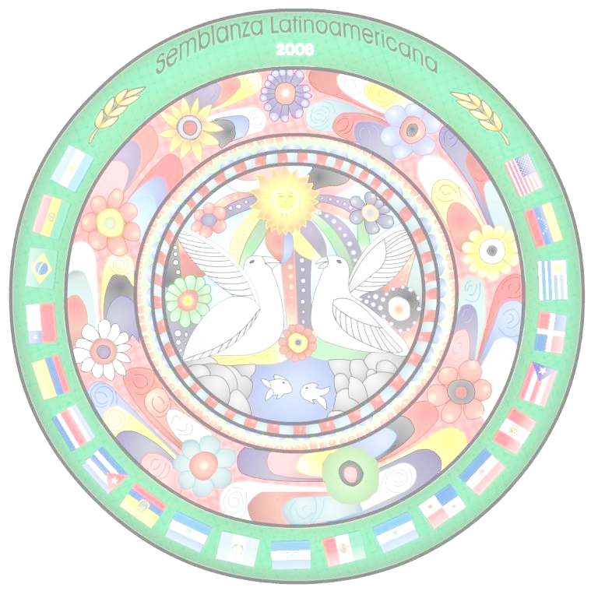
We are inviting dance companies that represent folk dances from the Americas and European countries to participate in this breathtaking event.

This year we will be celebrating our production at the HISTORIC LOS ANGELES THEATRE . There will be VIP parties, Art displays of costumes, paints, photos etc. Historical Tours from docents of the Theater Historical society .

Join us as we come together to explore one another traditions and celebrate the wonderful legacy that the Europe's many cultures have left in the Americas.
SEMBLANZA 2014
November 15th,2014
AT THE Los Angeles Theatre
615 S. Broadway , Los Angeles

SIGN UP NOW TO BE A PART OF THIS GREAT EVENT
Kindly respond by June 8th, 2014, via phone or email to Grace Vega at (562) 879-7860 or vtwingrace@aol.com to confirm your interest in this event.

Please send via email the following:
- Director / Representative, please send a video of your group performing (video does not have to be an edited performance, just something that will give us a good look at your current group performing).

- Also please send the following:
  - Director’s bio
  - Group bio or history
  - Photos of group (no more than 10 photos).
Note: this information needs to be submitted via email to: vtwingrace@aol.com

We appreciate your work and dedication in promoting your culture and keeping your traditions alive.
As part of SEMBLANZA 2014 your represented country will receive:
Monetary Compensation along with other rewards and recognitions.
A professional photo shoot * A professional DVD production of your performance *A special recognition from our City Representative* Media exposure and publicity *
Be a Part the celebration, register NOW!!!

Grace Vega
Director of Semblanza
vtwingrace@aol.com
www.tierrablancaartscenter.org I www.selatino.com
Contact us @ 562-879-7860
Classes & Workshops at :
Old Timers Foundation
3355 E Gage Ave, Huntington Park, CA 90255

